**MED D - Coordination of Benefits (COB) - Mail Order Update Only**

COB Claim Submission

Entering Beneficiary Supplied COB Information

Updating Beneficiary Supplied COB Information

Frequently Asked Questions

**Description:**  This document provides instructions on how to coordinate a beneficiary’s secondary benefits if the Plan/CIF Allows.

|  |
| --- |
| **COB Claim Submission** |

When the beneficiary has questions regarding claim submission and/or coordination of benefits, confirm eligibility to add COB information by checking the beneficiary’s CIF. Search for Coordination of Benefits (COB), review if it indicates a secondary benefit can be added for the client.

Top of the Document

|  |
| --- |
| **Entering Beneficiary Supplied COB Information** |

  This is for Coordination of Benefits for Mail Order only. CCRs must check CIF before doing the next steps. CIF will state if Mail order COB is allowed. If so, proceed to the next steps.

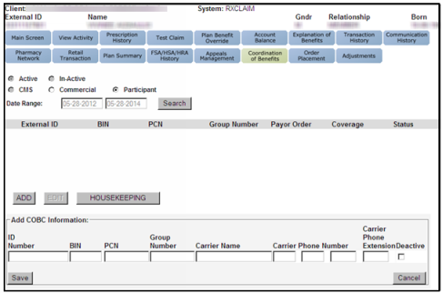

Perform the following steps:

|  |  |
| --- | --- |
| **Step** | **Action** |
| **1** | Select the **Coordination of Benefits** tab, then click the **Participant** radio button, click **Search** then click **Add**. |
| **2** | * Input the information about the additional coverage provided by the caller into the appropriate fields.   **Note:** The following information should be displayed on the beneficiary’s ID Card for the additional coverage:   * + ID number for the additional coverage   + Bank Identification Number (BIN)   + Processor Control Number (PCN)   + Group Number   + Carrier Name   + Carrier Phone Number   + Carrier Extension (optional)      * Suggest that the beneficiary confirm with their secondary insurance that CVS Caremark Mail Order Pharmacy is in their network. |
| **3** | Advise the beneficiary that if their coverage changes, they should contact Customer Care to update their records. |
| **4** | Verify that the information is correct and click **Save.**  **Note:**  COB information affects Mail Order claims only. |

Top of the Document

|  |
| --- |
| **Updating Beneficiary Supplied COB Information** |

 This is for Coordination of Benefits for Mail Order only. CCRs must check CIF before doing the next steps. CIF will state if Mail order COB is allowed. If so, proceed to the next steps.

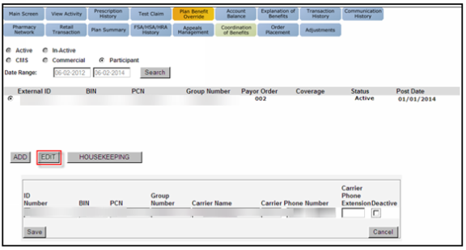

Perform the following steps:

|  |  |
| --- | --- |
| **Step** | **Action** |
| **1** | Select the **Coordination of Benefits** tab and click the **Participant** radio button then select **Search** and **Edit**. |
| **2** | Update the COB information as directed by the beneficiary.  **Note:**If the beneficiary is calling to state that the line of coverage is no longer active, click the **Deactive** checkbox.   COB information provided by the beneficiary cannot be deleted from the profile. |
| **3** | Verify the information is correct and click **Save**. |

Top of the Document

|  |
| --- |
| **Frequently Asked Questions** |

Refer to the below:

|  |  |
| --- | --- |
| **Question** | **Answer** |
| In regard to HIPAA, what authentication measures need to be taken when collecting COB information from a beneficiary/wife/dependent/authorized party? | If authentication was taken to view the account, then add secondary coverage. |
| If manufacturer coupons contain the same information as an ID card (BIN, PCN, Group, etc.); will they be able to be entered as COB information? | No. |
| My claim is rejecting due to other coverage? | Refer to [MED D - Coordination of Benefits (COB) - Claim Rejection](https://thesource.cvshealth.com/nuxeo/thesource/" \l "!/view?docid=c20ac611-54bb-4739-ad85-bdcf039c43c5) |
| I received a letter regarding other coverage on file? | Refer to [MED D - Coordination of Benefits (COB) - Letter Response](https://thesource.cvshealth.com/nuxeo/thesource/#!/view?docid=4886206c-87c0-4bb6-9872-a859aa30b3d8) |

Top of the Document

Not to Be Reproduced or Disclosed to Others without Prior Written Approval

**ELECTRONIC DATA = OFFICIAL VERSION / PAPER COPY = INFORMATIONAL ONLY**